


LOOK: Eye Glass Recommendation System Based on Face Shape Using Multi-Task CNN Models

A PROJECT PROPOSAL SUBMITTED FOR THE PARTIAL FULFILLMENT OF THE REQUIREMENTS OF THE HIGHER NATIONAL DIPLOMA IN DATA SCIENCE (FULL TIME) PROGRAMME.

Hemara Nimtharu (COHNDDS251F-012), Hamdha Saheer (COHNDDS251F-013),
Lakshika Nimandi (COHNDDS251F-014)
Higher National Diploma in Data Science
National institute of business management (NIBM)
Colombo, Sri Lanka.
Date of submission – 15th February 2026
Abstract
The problem of choosing glasses is a big problem for people who shop online and in stores. Choosing suitable eyeglasses is a significant problem for customers who shop in both online and offline stores. It often leads to dissatisfaction and high product return rates. Industry reports indicate that approximately 25-30% of purchased eyewear from online stores returns due to dissatisfaction in purchase. To address this issue, this research proposes the development of LOOK- an Eye Glass Recommendation System Based on Face Shape Using Multi-Task Convolutional Neural Networks (CNNs). This system leverages deep learning techniques to analyze the images provided by the customer and automatically identify key attributes such as face shape (heart, round, oval, square, and oblong), Gender, and age group. The core of the system is a multi- task CNN model capable of performing multiple classification tasks simultaneously, improving computational efficiency and predictive accuracy. LOOK will provide a 3D virtual try -on module, enabling users to recommend frames on their faces. So, we can enhance user confidence and reduce product return rates. Here, LOOK seeks to provide an intelligent, automated, and user-friendly decision support system for eyewear selection for customers.

Keywords: Multi-Task CNN, Deep Learning, Eye Glass Recommendation System, Face Shape Classification, Virtual Try-on, Personalized Recommendation, Artificial Intelligence
Table of Contents
1. Introduction 4
1.1 Background 4
1.2 Problem Statement 4
1.3 Research Rationale 4
1.4 Research Questions 4
2. Literature Review 4
2.1 Challenge 4
2.2 Key Studies 5
2.3 Research Gap 6
2.3.1 Missing Part 6
2.3.2 Project Filler 6
2.4 Research Gap 6
3. Research Objectives 7
3.1 General objective 7
3.2 Specific objectives 7
4. Methodology 7
4.1 Research Design 7
4.2 Data Collection 8
4.2.2 Dataset 8
4.2.2 Preprocessing Pipeline 8
4.3 Data Analysis Techniques 8
4.4 Tools and Software 8
4.5 Timeline 8
5. Expected Outcomes and Significance 10
5.1 Anticipated Results 10
5.2 Impact and Significance 10
5.3 Potential for Publication 11
6. Budget and Resources 11
6.1 Computing Resources 11
6.2 Data Resources 11
6.3 Software Tools (Open Source) 11
7. References 12
8. Appendices 13

Introduction

Background
The e-commerce trend has revolutionized the visual business, but the personal touch of a stylist is lost in the digital transaction. The advent of big data and computer vision provides a huge opportunity to leverage facial landmarking and deep learning to reimagine professional advice.

Problem Statement
Consumers also face challenges in the following areas:
Online: High return rates of 25-30% due to poor fit and/or style.
In-store: Too many choices leading to decision fatigue.
General: No personalized advice based on individual facial geometry.

Research Rationale
This project addresses the objectives of the HNDDS program by using deep learning (CNN) technology to optimize a real-world business process. This process involves transforming the “guessing” of shopping into a data-driven optimization problem.

Research Questions
- How accurately can a multi-task CNN model classify different face shapes compared to traditional manual methods?
- To what extent does the use of personalized AI recommendations reduce perceived decision fatigue for eyewear shoppers?

Literature Review

Challenge
The big problem with recommending things based on face shape is that people have very different ideas about faces. Some experts say that stylists usually think of 4 or 5 face shapes, such as round, oval, square, heart, and oblong. In fact, there are 11 very similar face shapes. So figuring out which face shape someone has is a challenge. Face shape makes this so difficult because it’s not easy to classify face shapes. Accurately telling the shape of a face is a problem with face shape-based recommendations. Also, since photos taken in real-life situations are never straight, face alignment is a major technical hurdle, so it’s necessary to perform complex rotation transformations on them before using a CNN for feature extraction. In business terms, a 25-30% return rate in online shopping shows that current technology fails to accurately convert 2D data into a comfortable 3D fit.

Key Studies
Author & Year | Title / Research Focus | Methodology / Data Science Tool | Key Findings
Thapa et al. (2025) | Web-Based AR Eyewear Try-On System | MTCNN for face detection for classification | Accuracy of 92% in face shape classification and seamless AR overlay
Perera & Wickramasinghe (2024) | AI Adoption in Sri Lanka's Retail Sector | Qualitative case study & Retail Survey. | Identified a "reality gap" where local retailers lack the technical expertise to deploy AI.
Ramadhan et al. (2022) | Eyeglasses Selection Based on Oval Face Shapes | Convolutional Neural Network (CNN). | Proved CNNs are more reliable than manual stylings for detecting subtle facial curves.
IIT / Westminster (2025) | Frame-Based AI Recommendation System | YOLOv8 (Object Detection) & Blazeface. | Highlighted the importance of color coordination alongside face shape for satisfaction.
PMC Health (2025) | Consumer Behavior in the Online Eyewear Market | Quantitative survey (N=85). | 29% reported bad fit/comfort in online-bought glasses, causing headaches and eye strain.
MDPI Fashion (2024) | Virtual Try-On Impact on Consumer Behavior | Systematic review of 69 articles. | VTO significantly reduces "purchase risk" and increases "adoption intention" in young adults.
Weerasinghe et al. (2025) | Deep Learning Approach for Beauty & Eyewear | Hybrid Feature Learning (CNN + SVM). | Hybrid models outperform single models by 15% when datasets are limited.
SSRN (2023) | AR as a Marketing Strategy in Sri Lanka | SSRN Tech Acceptance Model (TAM). | Found that "perceived ease of use" is Sri Lankans to try AR shopping.
IRJET (2022) | Face Shape Classifier Using Deep Learning | CNN with 10 Epochs. | Established a baseline accuracy of 82% for basic 5-category face shape recognition.
Lenskart Trends (2025) | Consumer Perception Toward Eyewear Channels | Descriptive Data Analysis. | Identified that consumers under 30 are 60% more likely to use AI features for frame selection.

Research Gap

Missing Part
Current research has focused heavily on the aesthetic (visual) aspect of glasses, with little integration with data on ergonomics and comfort. Most current AI models do not take into account the relationship between facial geometry and the physical discomfort caused by the term “poor fit.” No studies have been conducted for the Sri Lankan market, where a young, tech-savvy population is looking for an “affordable premium” option without a way to do it.

Project Filler
LOOK addresses these gaps by going beyond simple style classification. Instead, LOOK uses a multi-task CNN model that simultaneously predicts face shape, age, and gender. This provides a more complete recommendation solution. By using the “rule of contrast” (e.g., angular frames for round faces), LOOK addresses the discomfort issue identified in the current literature. Furthermore, LOOK allows for the integration of future PD measurements.

Research Gap
The following are the ethical guidelines closely followed by the project, which are important when processing sensitive information that involves:
- Informed consent: Users can give their consent after being informed about the use of the camera/image processing.
- Data confidentiality/anonymity: Real-time processing or high-level encryption is used.
- Data anonymization is performed to prevent excessive surveillance.
- Algorithmic fairness: It is ensured that there is no racial bias in the algorithm, as this is a major problem for CNN. Features from Sri Lanka and Southeast Asia are included.
- Transparency: There are no "black box" components for the user. The reason for choosing a certain frame based on facial features is explained to the user.

Research Objectives

General objective
To develop a deep learning-based recommender system to provide personalized eyewear recommendations based on facial geometry.

Specific objectives
- To implement MTCNN for high-accuracy face recognition and alignment.
- To develop a multi-task CNN for face shape classification, gender classification, and age classification.
- Implementing an AR-based virtual reality effort for real-time 3D glasses positioning.

Methodology

Research Design
This project will use an experimental design with a quantitative approach that uses a multi-task CNN architecture to process image data and produce classification classifiers for the recommendation engine. This project has three main modules: the data acquisition module, the multi-task CNN modeling module, and the recommendation engine module with deep learning and computer vision aspects.
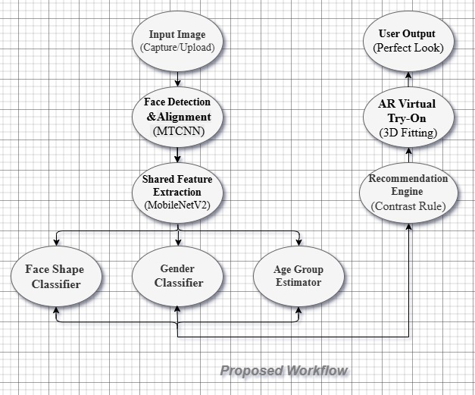

Data Collection

Dataset
The Face Shape Dataset developed by Kitsuchart Pasupa et al., and it contains 500 facial images categorized into five face shapes, such as Round, Oval, Oblong, Square, and Heart. Each class includes 100 images, ensuring balanced data distribution. This dataset is publicly available on GitHub (https://github.com/dsmlr/faceshape) and is used for face shape classification research.

Preprocessing Pipeline
- Input: Customer’s photo input
- Preprocessing: Images will be resized to 224x224 pixels, normalized, converted to RGB, and standardized.
- Detection: Face detection will be performed using MTCNN, followed by cropping and eye-level rotation.

Data Analysis Techniques
The core is a Shared Feature Extractor that feeds into three main classifiers:
- Face Shape: Oval, Round, Square, Heart, Oblong.
- Gender: Male, Female.
- Age Group: Child, Young, Old.

Tools and Software
- Frameworks: TensorFlow/Keras or PyTorch for CNN modeling.
- Libraries: OpenCV for image processing, Pandas/NumPy for data handling.
- Deployment: AR.js or similar for the virtual try-on experience.

Timeline
Phase | Week | Task Description | Deliverables
1. Initiation & Research | W1 | Identifying gaps in current eyewear AI solutions. | List of references
 | W2 | Scraping and labeling datasets | Cleaned Dataset
 | W3 | Data augmentation, normalization, and MTCNN face alignment. | Preprocessed Input Pipeline
2. Model Development | W4 | Defining the Shared Feature Extractor for the Multi-Task CNN. | Model Diagram
 | W5 | Training the Face Shape classification branch. | Training Logs (Accuracy/Loss)
 | W6 | Training the Gender and Age branches simultaneously. | Multi-Task Model Weight File
 | W7 | Testing the model against a validation set (Confusion Matrix). | Performance Metrics Report
3. System Integration | W8 | Mapping face shapes to specific frame styles | Logic Algorithm
 | W9 | Integrating the 3D Virtual Try-on using AR.js or OpenCV. | Working AR Prototype
 | W10 | Finalizing the user interface for the "LOOK" mobile/web app. | Final Integrated System
4. Finalization | W11 | User Acceptance Testing (UAT) and bug fixing. | Bug Report & Fixes
 | W12 | Completion of the report and VIVA preparation. | Final Proposal & Slides

Expected Outcomes and Significance

Anticipated Results
A deployable recommendation system with the following technological standards would be the primary output of the proposed project:
- Classification Accuracy: The classification of the five primary face shapes, which are round, square, oval, heart, and diamond, can be performed with a high accuracy of at least 85% by a Multi-Task CNN model.
- Real-time Performance: The performance of the system would be within two seconds of latency to provide a seamless surfing experience on mobile devices or online.
- Functional Prototype: The proposed project would be able to provide an interactive platform with a 3D AR virtual try-on feature.

Impact and Significance
This study provides great benefits in several areas:
- Business Application: The technology aims to reduce the current 25-30% return rate in online shopping for eyewear by improving the accuracy of fits.
- Customer Experience: By providing automatic and personalized style suggestions, it removes the customer experience of "decision fatigue" and "overwhelm" from both in-store and online shoppers.
- Social Impact: By using a computerized system, customers in the rural area can receive expert-level optical suggestions.
- Skill Alignment: It shows a high level of expertise in the processes related to data science, especially in the areas of data wrangling, machine learning, and deep learning.

Potential for Publication
This research has tremendous potential as it involves multi-task learning for face shape, age, and gender classification, which is a relatively new approach within the Sri Lankan environment. Giving a presentation on computer vision conferences/data science conferences, such as SLAAI conferences. Publication of research papers within regional journals that have an emphasis on digital retail innovation and artificial intelligence.

Budget and Resources

Computing Resources
Hardware: For the initial model prototyping, a basic workstation or a laptop with at least 8 GB RAM will be necessary (We have just 4 GB).
Processing Power: The study will be able to take advantage of the high-performance computing capabilities provided by Google Colab's Free Tier for training the deep learning model, utilizing the cloud-based GPU (Tesla T4) to process the CNN training computations.

Data Resources
Datasets: In order to ensure regional accuracy, the study will utilize a combination of publicly available facial images (e.g., "Face Shape Dataset" available on Kaggle) and a primary dataset of 50-100 local images collected with informed consent.

Software Tools (Open Source)
Programming Language: Python 3.12 will be the chosen programming language.
Deep Learning Framework: The study will be able to select either PyTorch for CNN model development or TensorFlow and Keras.
Computer Vision: The study will be able to select either MTCNN and OpenCV for facial image alignment and preprocessing.
Visualization: Matplotlib for training accuracy/loss curves and draw.io for architectural diagrams.

References
[1] P. Thapa, S. R. Shrestha, and S. Bajracharya, "A Web-Based AR-Powered Virtual Eyewear Try-On System," Innovative J. Eng. Technol., vol. 1, 2025, from https://nepjol.info/index.php/injet/article/download/78599/60206/226064
[2] A. Bozkurt et al., "Toward cyber-enhanced working dogs for search and rescue," IEEE Intell. Syst., vol. 29, no. 6, 2014, from https://ieeexplore.ieee.org/document/6914468/
[3] N. Ramadhan, T. R. Alyndra, and S. Syam, "Eyeglasses frame selection based on oval face shape using a convolutional neural network," ResearchGate, 2022, from https://www.researchgate.net/publication/360884792_Hybrid_Based_Model_Face_Shape_Classification_Using_Ensemble_Method_for_Hairstyle_Recommender_System
[4] S. Sandatharaka and J. Wickramasinghe, "Rhetoric and reality of artificial intelligence in apparel sector in Sri Lanka: A comparative case study," ResearchGate, 2024, from https://www.researchgate.net/publication/388220363_Rhetoric_and_reality_of_artificial_intelligence_in_apparel_sector_in_Sri_Lanka_comparative_case_study
[5] G. Gupta, "Deep Learning in Virtual Try-On: A Comprehensive Survey," Scribd, 2024, from https://www.scribd.com/document/803556482/Deep-Learning-in-Virtual-Try-On-A-Comprehensive-Survey
[6] P. Bhandari, "Consumer Behavior in the Online Eyewear Market," PMC Health, 2025, from https://pmc.ncbi.nlm.nih.gov/articles/PMC11945730/
[7] V. Hacısüleyman and M. Özger, "Optimal cropping patterns using linear programming and evaluation based on food-energy-water nexus," Glob. J. Environ. Sci. Manag., 2024, from https://doi.org/10.22034/gjesm.2024.SI.01
[8] T. Hale, "This Map Tells You If You'll Be Vaporized By An Atomic Bomb," IFLScience, 2018, from https://www.iflscience.com/editors-blog/this-map-tells-you-if-youll-be-vaporized-by-an-atomic-bomb/
[9] Ministry of Technology, "AI White Paper March 2024," Government of Sri Lanka, 2024, from https://mot.gov.lk/assets/files/AI%20White%20Paper%20March%202024-c09aa49f7990358ad1442103b804511d.pdf
[10] J. Caulfield, "IEEE Website Citation | Guide with Examples," Scribbr, 2023, from https://www.scribbr.com/ieee/ieee-website-citation/

Appendices
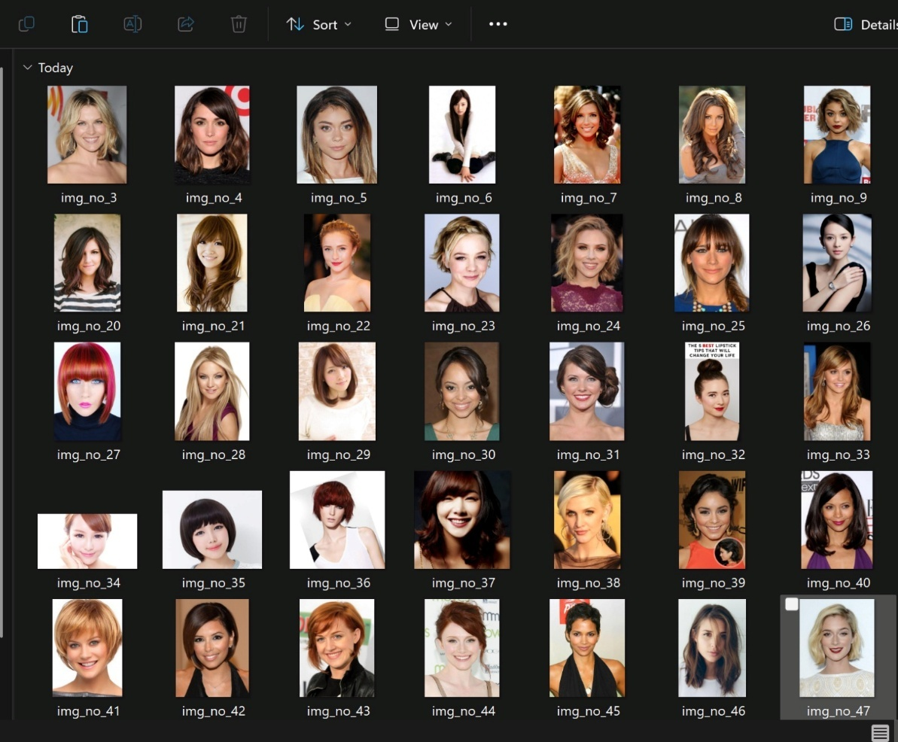

Code shows the image data loading, Augmentation and Multi-modeling.
